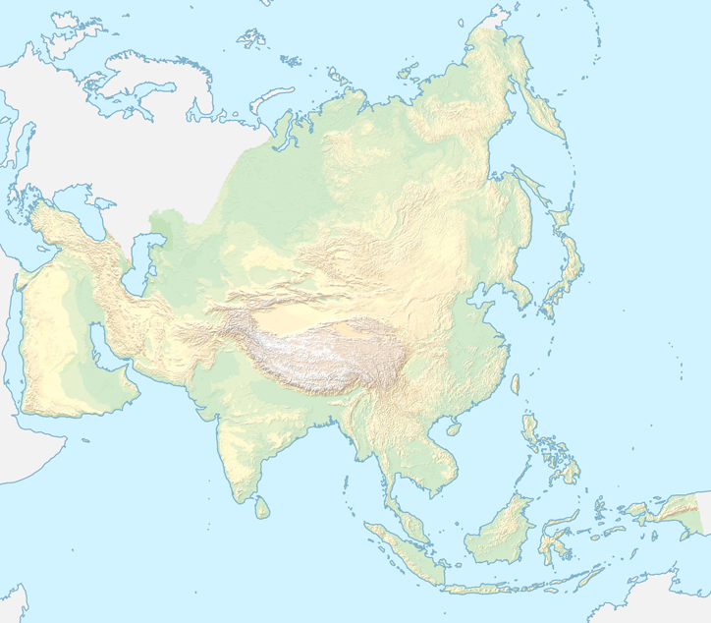

**AZIJA**

Vir: <http://gis.si/egw/GSS_T03_P11/index.html> (10. 4. 2020)