Be Social-Network Smart
(https://www.youtube.com/watch?v=PrJ1IWRiWt8)
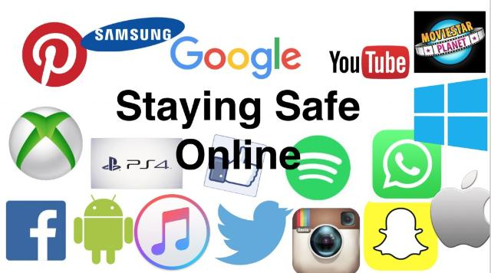
Watch the video and do the tasks.
- Odgovori na vprašanja.
- Do you use social networks?
- What social networks do you use?
- What are you usually up to in social networks?
- Can a social network be dangerous? Why?

- Poveži besede z istim pomenom.
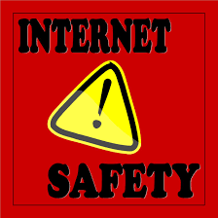
Word list: log in, watch out, hang around, post, to be up to, share.
- connect to a computer system – _____________________;
- associate with – __________________;
- give your photos, posts and other info to other people online – _____________;
- be careful with – _________________;
- to set some info online – __________________;
- to be going to do __________________.

- Spodnje iztočnice smiselno razvrsti v razpredelnico.
What you CAN do in a social network | What you MUSTN’T do in a social network | What you SHOULD do in a social network
_____________________________  _____________________________  _____________________________  _____________________________  _____________________________  _____________________________  _____________________________  _____________________________ | _____________________________  _____________________________  _____________________________  _____________________________  _____________________________  _____________________________  _____________________________  _____________________________ | _____________________________  _____________________________  _____________________________  _____________________________  _____________________________  _____________________________  _____________________________  _____________________________

connect to people,
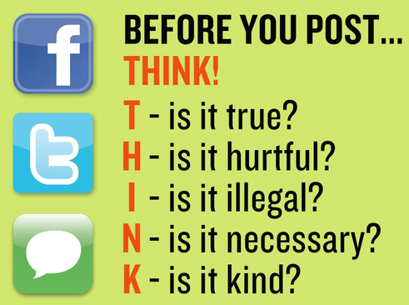
- tell people when you are going on vacation,
- share your photos,
- share information with people you don’t know online,
- listen to favourite songs,
- tell jokes,
- post info that may compromise your reputation,
- set some limits on using social networks,
- see what your friends are up to,
- post personal information,
- post information you wouldn’t like to see in news or in newspapers,
- be picky in choosing your online friends,
- let your online life get the better of your real life.

- Say what rules of Internet safety are violated in the pictures.
Word list: posting compromising info, telling jokes, Internet bullying, telling online you aren’t at home, sharing your photos, Internet blackmailing.

- 2) 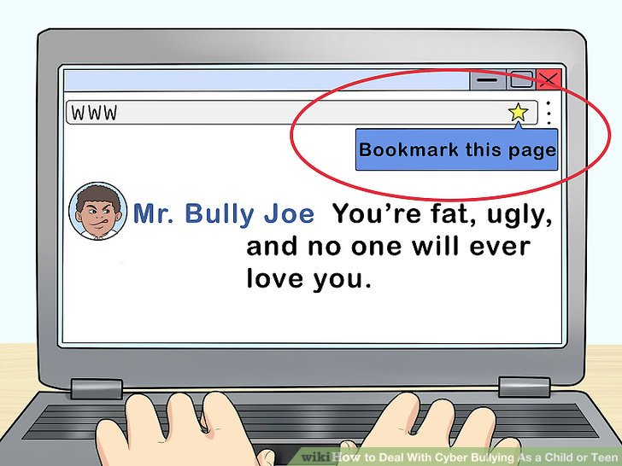

__________________________________ _____________________________________

___________________________________ _____________________________________

3) 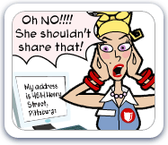 4) 

 

 

