5a TJA LAŽJE
2. ura
6 teden (20.4.-24.4.2020)

Dear kids, first I would like you to repeat words connected to food, by completing the crossword Wbp. 71. What's the proverb?

Učenci, hrano ponovite še tako, da rešite križanko v delovnem zvezku na strani 71.

Kakšno je geslo?

THE TIME

Watch the power point Telling time, where the time is explained.

Najprej si poglejte power point Telling time, o tem, kako se pove, koliko je ura v angleščini.

Then look at the worksheet The time. If you can, you can stick the worksheet into your notebooks. Otherwise rewrite the words.

Poglejte si učni list The Time. Kdor lahko, naj si prilepi učni list v zvezek, ostali si prepišite.

Now practice the time. Draw the clocks in your notebooks and write the time.
V zvezek prilepite ure in vadite zapis.

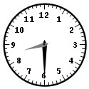 |  | 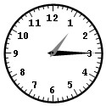
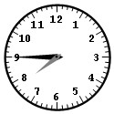 |  | 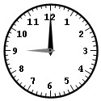
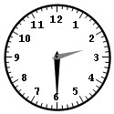 |  | 

