HOW GOOD IS YOUR ENGLISH?
Preverjanje pred pisnim ocenjevanjem znanja

Name (Ime in priimek):_____________________ Points (Točke): ___/ 64
Class (Razred): ________
School-year 2019/20

- Label the food and drinks. Označi hrano in pijačo.
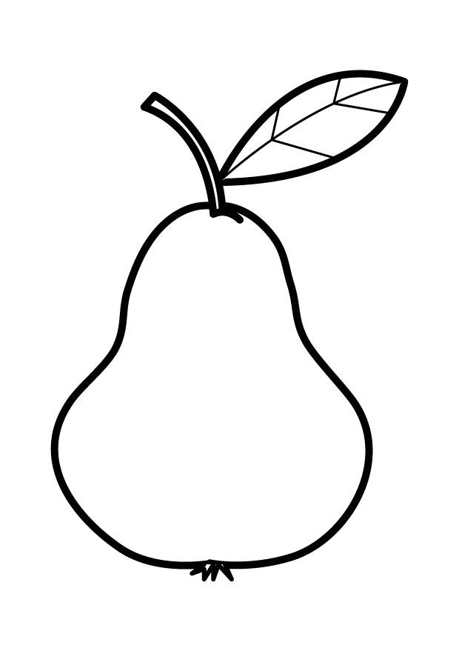
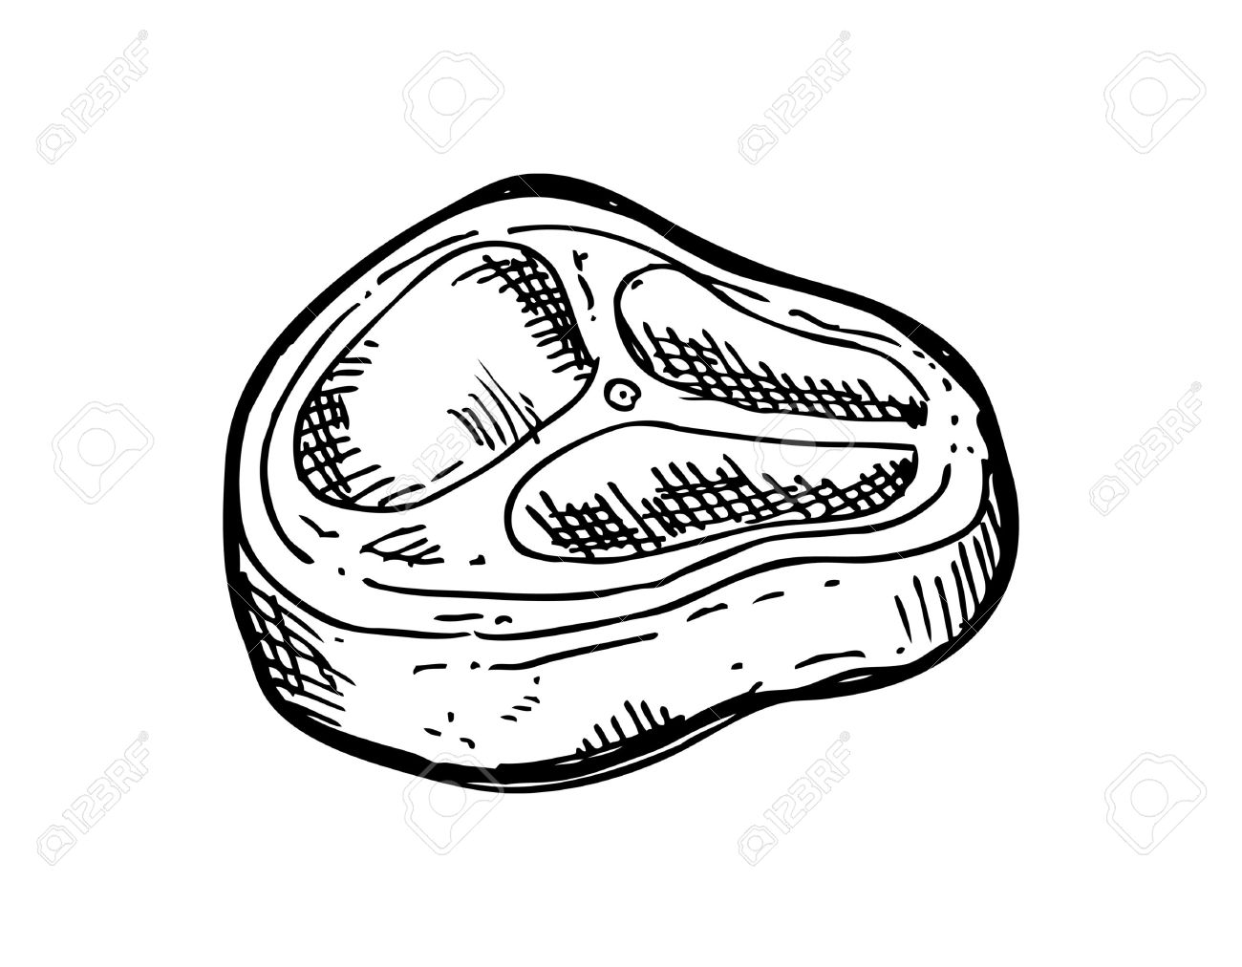
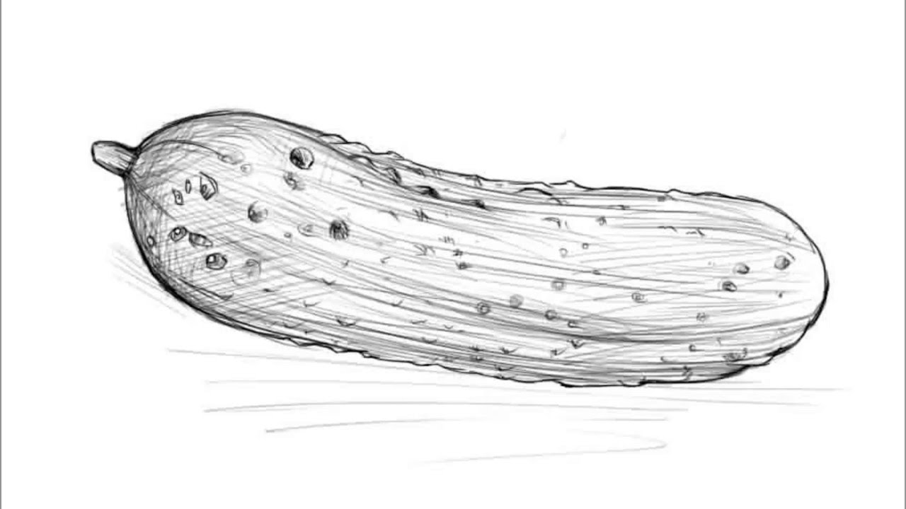

____________ ____________ ____________ ____________
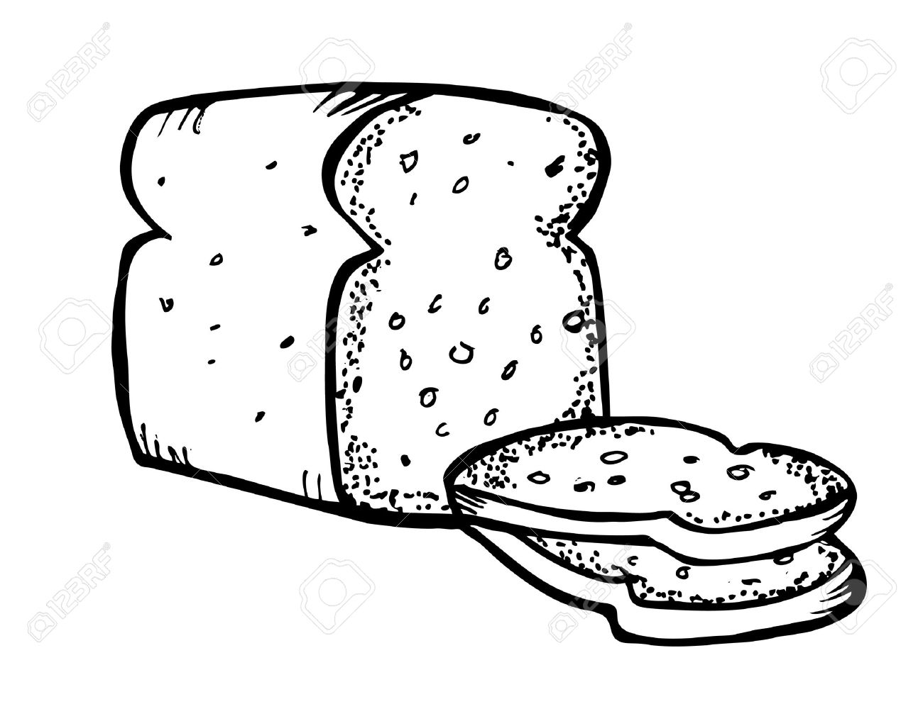
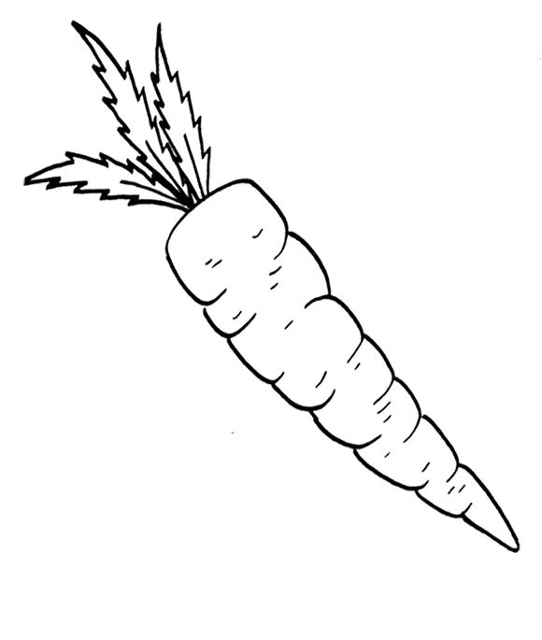
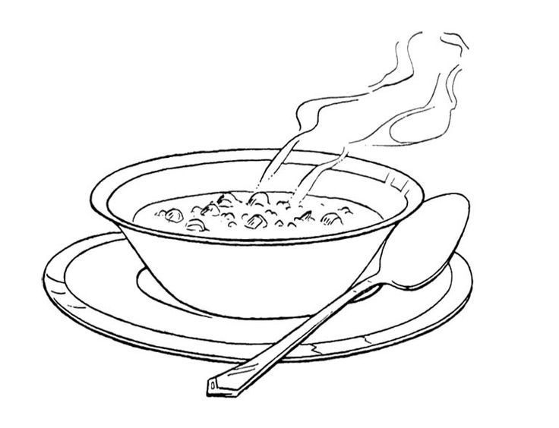

____________ ____________ ____________ ____________
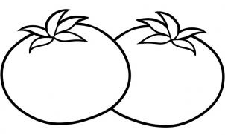
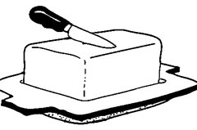

____________ ____________ ____________ ____________

/12

- Look at the symbols and write what this people like or don’t like. Glej simbole in zapiši, kaj je ljudem všeč in kaj jim ni všeč.

cheese I ______________________________________

chips Mary __________________________________

broccoli I ______________________________________

fish My mum _______________________________

/4
- Write the names of the missing days. Napiši imena manjkajočih dni.

MONDAY, ___________________, _____________________, THURSDAY,

___________________, __________________, _________________ .

/5

- Complete the sentences with EAT or EATS and the word in the box. Dopolni z EAT ali EATS in besedo iz okvirja.
leaves everything mice worms

A pig ___________________ _________________.
Turkeys ________________ ___________________.
A goat __________________ ____________________.
Cats __________________ ____________________.
/4
- Insert the missing words. Vstavi manjkajoče besede.
bed go for breakfast like

2 o’clock eat TV drink

I’m Mary. I have ___________________ at 7 o’clock in the morning.

I ______________ to school at 8 o’clock. I ______________ lunch at 12 o’clock.

______________ lunch I eat meat and chips and I _______________ juice.

I ________________ juice but I don’t like water. I do my homework at _____________.

I watch ________________ at 5 o’clock. I go to _______________ at 9 o’clock.

/9

- What’s the time? Koliko je ura?

__________________ ____________________ __________________

/3

- Write the opposite adjectives. Zapiši nasprotja.

LAZY - ____________________ SLOW - _____________________

BRAVE - ___________________ FAT - _____________________

DANGEROUS - ______________ STRONG - __________________
/6

- Answer the questions. Odgovori na vprašanja.

- What does a dog eat? ________________________________________________.

- What does a hen give to people? _______________________________________.

- What can a kangaroo do? _____________________________________________.

- What can’t a dolphin do? ______________________________________________.

/4

- Read the description and name the animal. Preberi opis in poimenuj žival.

This animal is very strong and brave. It is a big cat. It has got black and yellow stripes.
__________________
This animal is very big and very lazy. It likes sleeping in dirty water.
___________________
This animal is very naughty. It can jump from tree to tree. It lives in Africa and Asia.
___________________
This animal is a bird. It has got wings but it can’t fly. It can swim very well. It lives in cold places like Antarctica.
___________________
This animal is the biggest animal in the world. It lives in the sea. It eats fish and small animals that swim in the ocean.
_____________________
/5
- Read and answer the questions. Preberi in odgovori na vprašanja oz. obkroži pravilen odgovor.

SUNDAY FUN

My name is Ben. I love Sundays because there is no school. In the morning, I usually get up at 9 o’clock. After breakfast, I stay in my room and read comic books. I love action stories like Iron Man and Spiderman. In the afternoon, I usually go to the park with my friends. We like to play basketball there. Before dinner, I watch cartoons on TV with my brother. Then I get ready for school next day. Sundays always seem so short, and I wish they were longer.

- What’s his name? _____________________________________
- What is his favourite day? _______________________________
- When does he get up? __________________________________
- What does he do in the park? ____________________________
- He watches TV with his: FRIEND BROTHER
- Sundays are: SHORT LONG
/6

- Describe the ELEPHANT. Opiši SLONA (poimenuj dele telesa, značaj, kaj zmore, kaj je).
________________________________________

________________________________________

________________________________________

________________________________________

________________________________________

__________________________________________________________________

__________________________________________________________________

/6

