VOCABULARY: The House

- ROOMS IN THE HOUSE and objects
1. | The bathroom
2. | The garage
3. | The bedroom
4. | The kitchen
5. | The living room
6. | The alarm clock
7. | The balcony
8. | The work office
9. | The table
10. | The corridor
11. | The hall
12. | The cellar
13. | The terrace
14. | The toilet
15. | The stairs
16. | The dining room
17. | The picture
18. | The attic
19. | The roof
20. | The chimney

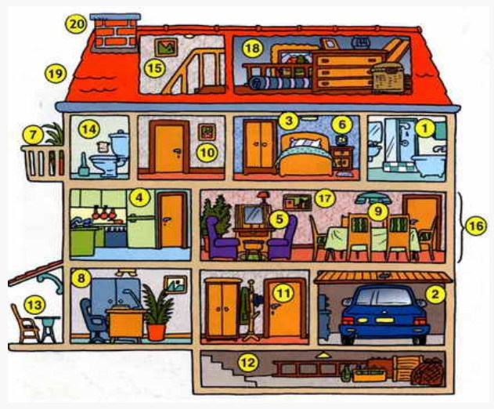
1. | bathtub
2. | fireplace
3. | mirror
4. | office chair
5. | bookcase
6. | desk and chair
7. | wardrobe
8. | computer
9. | fridge freezer
10. | radiator
11. | cooker
12. | armchair
13. | mirowave oven
14. | dining chai
15. | door

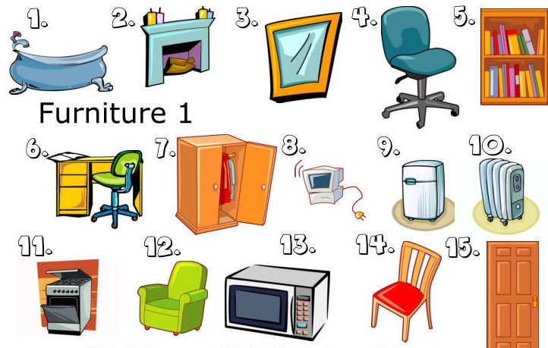

1. | sink
2. | chest of drawers
3. | stairs
4. | lamp
5. | cabinet
6. | sofá
7. | washing machine
8. | dresser/sideboard
9. | plant
10. | window
11. | bed
12. | table
13. | bath and shower
14. | carpet
15. | toilet

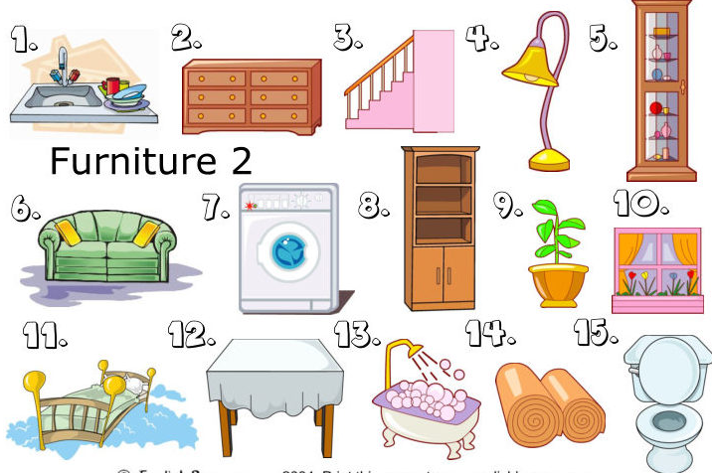

A. PREPOSITIONS OF PLACE
B. SHOWING EXISTENCE: The verb “There be”
There be | Affirmative | Negative | Interrogative | Answers
Singular | There is a lamp. | There isn’t a door. | Is there a hall? | Yes, there is  No, there isn’t
Plural | There are drawers. | There aren’t chairs. | Are there mirrors? | Yes, there are  No, there aren’t
1. Label the picture and then write sentences using there is/are locating objects.
(Zapiši ustrezne številke k predmetom na sliki.)
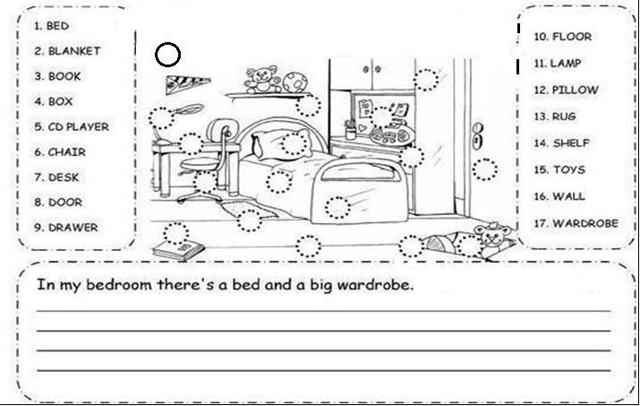
2. Look at the picture and complete with there is/isn’t or there are/aren’t:
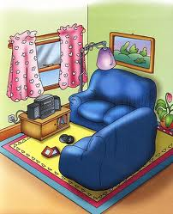
(Glej sliko in dopolni z: there is/isn’t ali there are/aren’t.)

1. ____________ a TV in the living room.
2. ____________ a picture on the wall.
3. ____________ two sofas in the room.
4. ____________ three chairs and a table.
5. ____________ a rug under the sofas.
6. ____________ a stereo set under the window.

3. Look at the picture and complete with is/are and a place preposition: IN FRONT OF, ON, UNDER, BETWEEN, NEXT TO
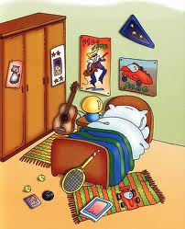
(Glej sliko in dopolni z: is ali are in zgoraj navedenimi predlogi kraja.

1. There _____ a guitar _____ the wardrobe and the night table.
2. There _____ two tennis balls _____ the floor.
3. There _____ a rug _____the guitar.
4. There _____ a toy car _____ the magazine.
5. There _____ two posters _____ the wall.
6. There _____ a tennis racket ____________ the bed.
7. There _____ a rug ________ the bed and the wardrobe.
8. There _____ a lamp ________ the nightable.

4. Look at the picture and write sentences using there is/isn’t or there are/aren’t and prepositions of place. (Glej sliko in jo opiši. Pomagaj si s prejšnjo nalogo.)
