Score
12

Name: Subject: Year 5 Geography Date: Sheet: Cloze activity - Water facts

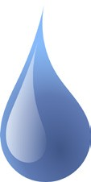 Cloze Activity - Water Facts
ice
undrinkable
pollution
solid
dehydrated
surface
oxygen
seawater
life
rivers
Pacific
Nile

Read the facts about water below and fill in the missing words from the word bank.

- Water is made up of two elements, hydrogen and .

- Water is essential for on Earth.

- Water covers around 70% of the Earth’s .

- The longest river in the world is the River.

- Water and low quality water can lead to dangerous bacteria, disease and viruses.

- Water has three different states, liquid, and gas.

- Nearly 97% of the world’s water is salty or .

- When our bodies haven’t had enough water it is called being .

- The Ocean is the largest ocean in the world.

- Freshwater can be found in lakes, and streams.

- Water from a sea or ocean is known as .

- The solid state of water is known as and the gas state of water is known as steam or water vapour.

© Primary Leap Ltd. 2020 www.primaryleap.co.uk - Primary Resources

